

Semester Two Examination, 2021
Question/Answer booklet

MATHEMATICS
METHODS
UNITS 1&2
Section One:
Calculator-free

Your name

Number of additional
answer booklets used
(if applicable):

Time allowed for this section
Reading time before commencing work: five minutes
Working time: fifty minutes

Materials required/recommended for this section
To be provided by the supervisor
This Question/Answer booklet
Formula sheet

To be provided by the candidate
Standard items: pens (blue/black preferred), pencils (including coloured), sharpener,
correction fluid/tape, eraser, ruler, highlighters

Special items: nil

Important note to candidates
No other items may be taken into the examination room. It is your responsibility to ensure that you do not have any unauthorised material. If you have any unauthorised material with you, hand it to the supervisor before reading any further.

Structure of this paper

Section | Number of  questions  available | Number of  questions to  be answered | Working  time  (minutes) | Marks  available | Percentage  of  examination
Section One:  Calculator-free | 8 | 8 | 50 | 52 | 35
Section Two:  Calculator-assumed | 13 | 13 | 100 | 98 | 65
 |  |  |  | Total | 100

Markers use only
Question | Maximum | Mark
1 | 5
2 | 6
3 | 6
4 | 7
5 | 7
6 | 7
7 | 7
8 | 7
S1 Total | 52
S1 Wt (×0.6731) | 35%
S2 Wt | 65%
Total | 100%

Instructions to candidates

1. The rules for the conduct of examinations are detailed in the school handbook. Sitting this examination implies that you agree to abide by these rules.

2. Write your answers in this Question/Answer booklet preferably using a blue/black pen.
Do not use erasable or gel pens.

3. You must be careful to confine your answers to the specific question asked and to follow any instructions that are specific to a particular question.

4. Show all your working clearly. Your working should be in sufficient detail to allow your answers to be checked readily and for marks to be awarded for reasoning. Incorrect answers given without supporting reasoning cannot be allocated any marks. For any question or part question worth more than two marks, valid working or justification is required to receive full marks. If you repeat any question, ensure that you cancel the answer you do not wish to have marked.

5. It is recommended that you do not use pencil, except in diagrams.

6. Supplementary pages for planning/continuing your answers to questions are provided at the end of this Question/Answer booklet. If you use these pages to continue an answer, indicate at the original answer where the answer is continued, i.e. give the page number.

7. The Formula sheet is not to be handed in with your Question/Answer booklet.
Section One: Calculator-free 35% (52 Marks)
This section has eight questions. Answer all questions. Write your answers in the spaces provided.

Working time: 50 minutes.

Question 1 (5 marks)
The quadratic function $f\left(x\right)=ax^{2}+bx-6$ has roots at $x=1$ and $x=-3$.

(a) Determine the value of the constant $a$ and the value of the constant $b$. (3 marks)

(b) State the range of the function $f$. (2 marks)

Question 2 (6 marks)
(a) Evaluate $f'(3)$ when $f\left(x\right)=10x^{2}-5x^{4}$. (2 marks)

(b) Determine $\begin{matrix}d \\ \overline{dx}\end{matrix} \left(\left(5x-6\right)\left(5x+6\right)\right)$. (2 marks)

(c) The volume of water in a tank at time $t$ seconds is given by $V\left(t\right)=t^{3}-3t+1$ cm³. Determine the instantaneous rate of change of volume when $t=5$. (2 marks)

Question 3 (6 marks)
(a) Solve ${\left(x-8\right)}^{2}-16 =0$. (2 marks)

Let $g\left(x\right)=x^{3}-5x^{2}+2x+8$.

(b) Evaluate $g(2)$. (1 mark)

(c) Factorise $g\left(x\right)$. (3 marks)

Question 4 (7 marks)
(a) Determine the function $f$ given that $f\left(1\right)=5$ and $f^{'}\left(x\right)=3-4x$. (3 marks)

(b) Determine the equation of the tangent to the curve $y=x^{4}+4x^{3}-10x-2$ at the point where $x=-2$. (4 marks)

Question 5 (7 marks)
(a) The first term of an arithmetic sequence is $6$ and the ${13}^{\text{th}}$ term is three times the $4^{\text{th}}$ term. Determine the sum of the first $12$ terms of this sequence. (4 marks)

(b) Determine $S_{∞}$ for the following geometric sequence:
(3 marks)
$$\frac{5}{3}, \frac{5}{9}, \frac{5}{27}, \frac{5}{81}, …$$

Question 6 (7 marks)
Let $f\left(x\right)=2^{x-3}$.

(a) Sketch the graph of $y=f(x)$ on the axes below. (3 marks)

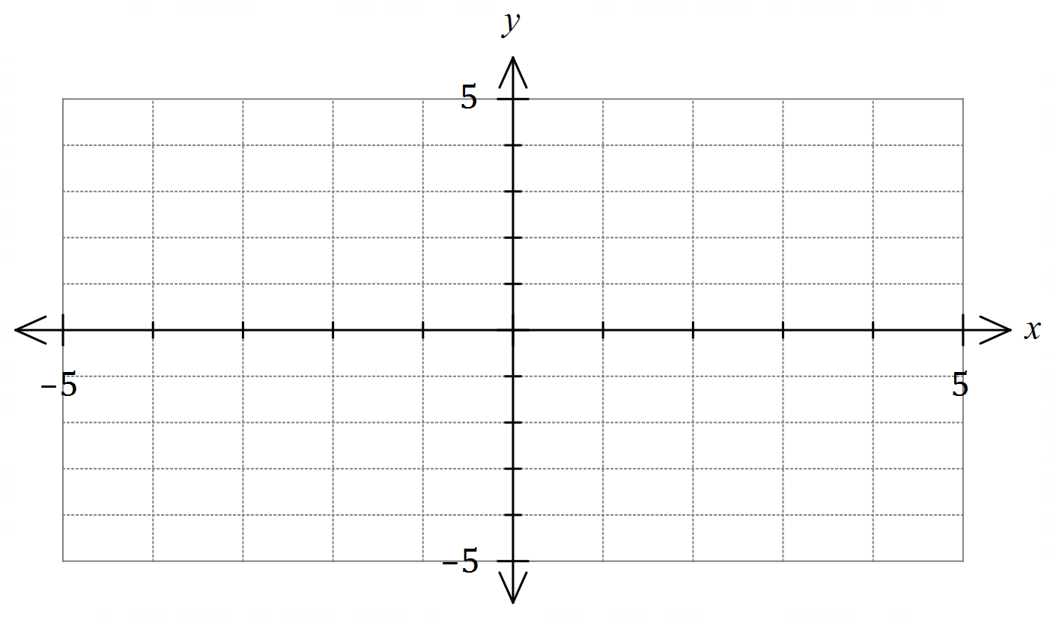

(b) Solve $f\left(x\right)=\sqrt[3]{2}$ for $x$. (2 marks)

(c) Evaluate $f\left(\frac{1}{2}\right)$, giving your answer in simplest form without the use of indices. (2 marks)

Question 7 (7 marks)
(a) Solve the equation $\tan\left(2x-10°\right)=\sqrt{3}$ when $0≤x≤180°$. (3 marks)

(b) In triangle $ABC$, the length of side $AC$ is $9$ cm, $\sin{C}=0.4$ and $\sin{B}=0.6$. Determine the length of side $AB$. (2 marks)

(c) Triangle $PQR$ has sides of length $4, 5$ and $6$ cm. Given that $PQ$ is the shortest side in the triangle, determine the value of $\cos{R}$. (2 marks)

Question 8 (7 marks)
Determine the coordinates of the point(s) where the line $x-2y=5$ intersects the circle with centre $(2, 1)$ and radius $5$.

Supplementary page

Question number: _________

© 2021 WA Exam Papers. Kennedy Baptist College has a non-exclusive licence to copy and communicate this document for non-commercial, educational use within the school. No other copying, communication or use is permitted without the express written permission of WA Exam Papers. SN245-182-1.

